

# *UniX and Linux Essentials*

**ASSIGNMENT -12**

**SUBMITTED BY:**

**AYUSH KUMAR JHA**

**SAP ID - 500086400**

**Enrollment no - R200220083**

**B.C.A -I.O.T.**

**Assignment 12 :-**

* **Ps current running processes.**

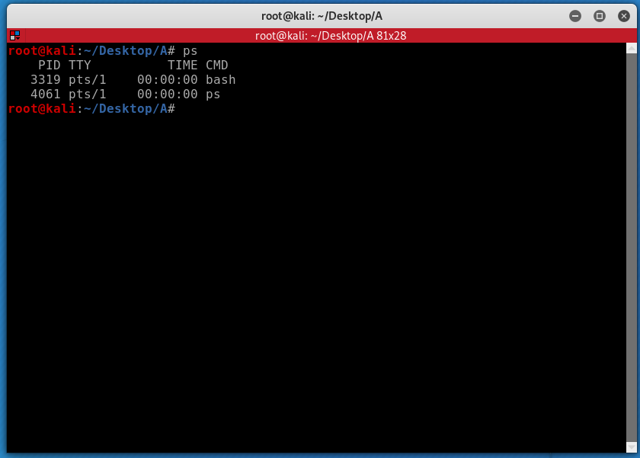

* **Show current running processes.**

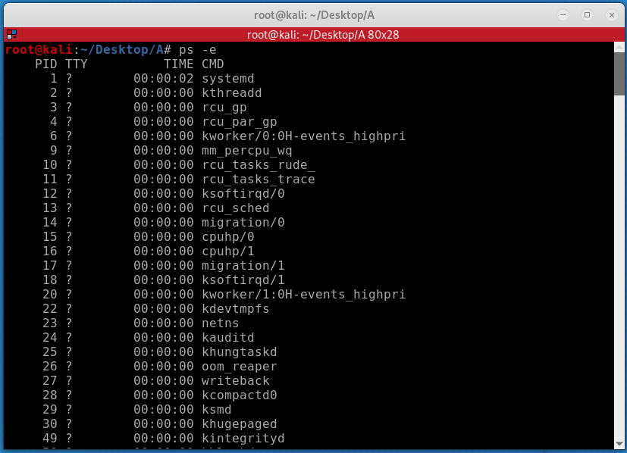

* **Generating list**

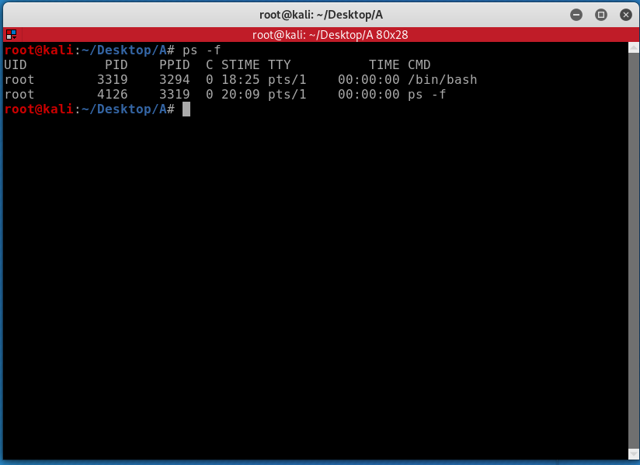

* **Generating long list**

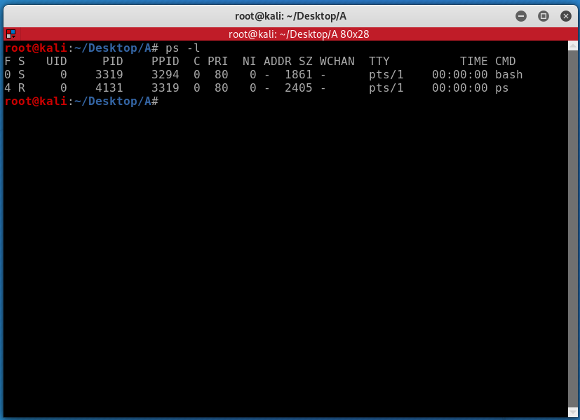

* **Show the current running and long list**

